Master of Ceremony Dr. Christopher Johnson
Welcome Dr. Erika Endrijonas
Congratulations Dr. Joshua Ramirez

SERVICE TO THE COLLEGE AWARDS

ASSOCIATED STUDENT GOVERNMENT
Angela Alexander Marco Bonometti
Mason Brown Michael Galeck
Thomas Gordon Samuel Gustafson
Soleá Heredia Ariana Hosseini
Madison Journey Jasmine Messina
Alexandra Raphael Kaila Service
Leo Smith Zoe von Transehe-Roseneck
Riley Wilson Mimi Yamasuga
Outstanding Club………………………………………The Biology Club
DSPS………………………………………………………………Sole Arevalo
EOPS - Adolfo Corral Award…………………Juan Anguiano Zavala
EOPS - CalWORKs/CARE…………………………………Nayelli Mireles
EOPS - NextUp/Guardian Scholars……………………Leandra Harris
Enrollment Services………………………………………………May Pyae
¡Raíces: First Year and Beyond!………………Alize Martinez-Madrid
Student Equity & Engagement Programs -
Basic Needs Center………………………………………………Liliana Shi
Student Equity & Engagement Programs -
Centers for Equity & Social Justice……Mitzi Ojendis Hernandez
Student Equity & Engagement Programs -
Pride Center…………………………………………………Max Ruvalcaba
Student Equity & Engagement Programs -
Rising Scholars……………………………………………Daniel Vasquez
Student Health Services - The WELL…………………Blaze Osborne
Umoja…………………………………………………………Sabrina Machira Veterans Support Services……………………………Xzavier Chancay
Welcome Center………………………………………………Thet Htet San

ACADEMIC AWARDS

SOCIAL SCIENCES
American Ethnic Studies………………………………Cecilia Moscatelli
American Ethnic Studies - Asian Studies………………Goldie King
American Ethnic Studies - Black Studies………………Dillan Scott
Anthropology - Archaeology……………………………Thet Htet San
Global Studies………………………………………………Megan Balents
Philosophy………………………………………………………Audrey Fuette
Political Science and Law and Society………………Maya McGrane
Psychology…………………………………………………………Citlali Ruiz

ATHLETICS
Health, Physical Education, Dance and Athletics………………………………………………………Kaylee Lawson

HEALTH AND HUMAN SERVICES
Vocational Nursing………………………………………Andrea Angeles
Medical Imaging Sciences/Radiography…………Liza Breitenstein and Zachary Steinberger
School of Justice Studies………………………Juan Anguiano Zavala

SCIENCES
Biological Science…………………………………………Shane Grummitt
Computer Science……………………………………………Alfred Morgan
MATHEMATICS
Math.…………………………………………………………Lemoni Genosar

HONORS PROGRAM
Phi Theta Kappa…………………………………………Marco Bonometti

MIDDLE COLLEGE
Dual Enrollment-Middle College……………………………Sway Moore

ACADEMIC AWARDS

TECHNOLOGIES
Environmental Horticulture………………………Genevieve Pelletier

ENGLISH AS A SECOND LANGUAGE/SCHOOL OF MODERN LANGUAGES
English as a Second Language……………………Berenice Camargo

INTERNATIONAL STUDENTS PROGRAM
International Students Program……………………Cecilia Moscatelli

ENGLISH
English………………………………………………………Amelia Lundgren

FINE ARTS
Journalism………………………………………………………Michael Lopez
Theater………………………………Adrian Arias and Charlotte Hecker
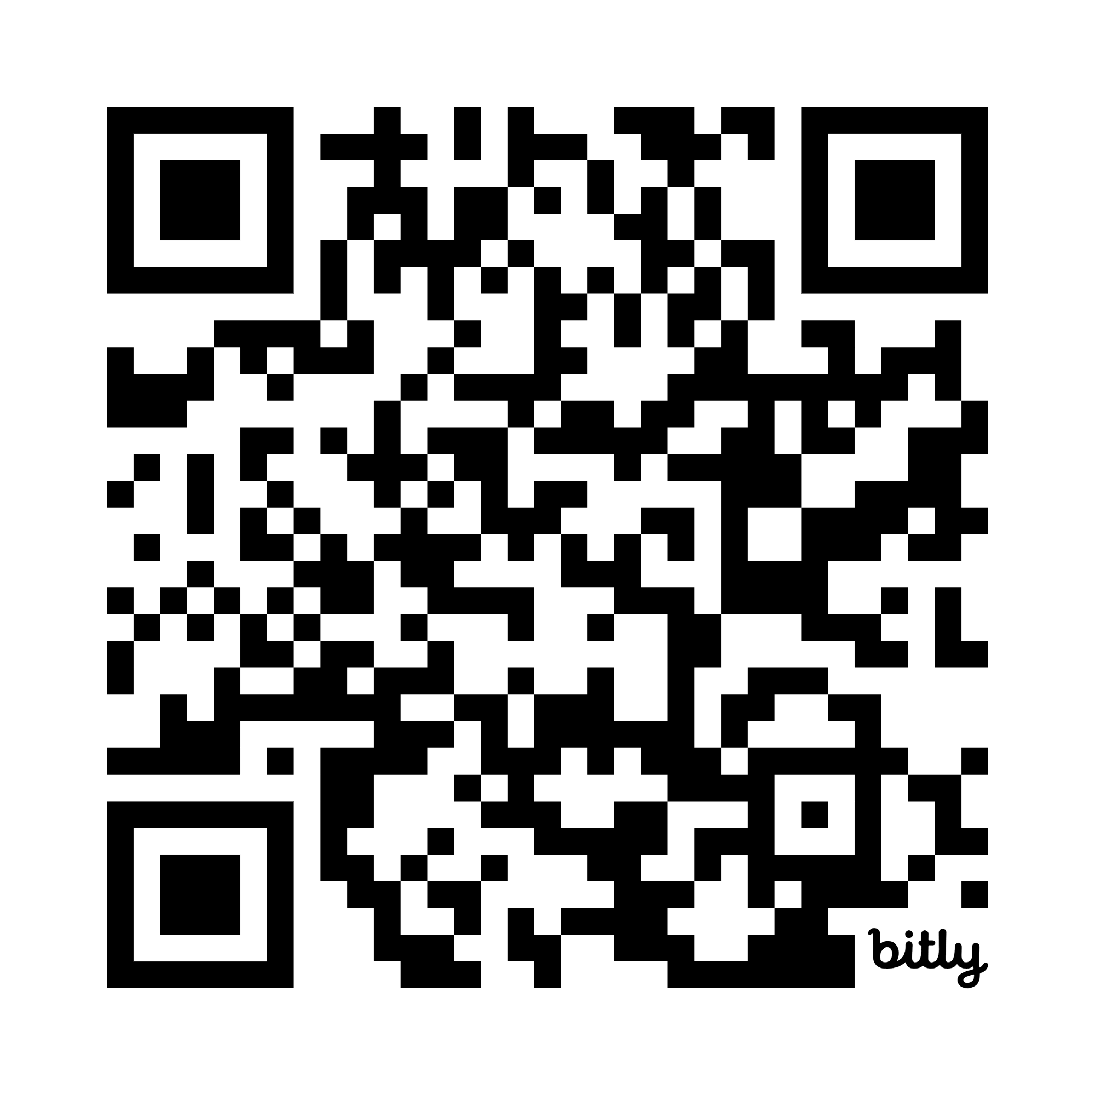

see website 👆 for selected students and write-ups
SPECIAL THANKS TO
Amy Collins Event Coordinator
SBCC Catering Catering

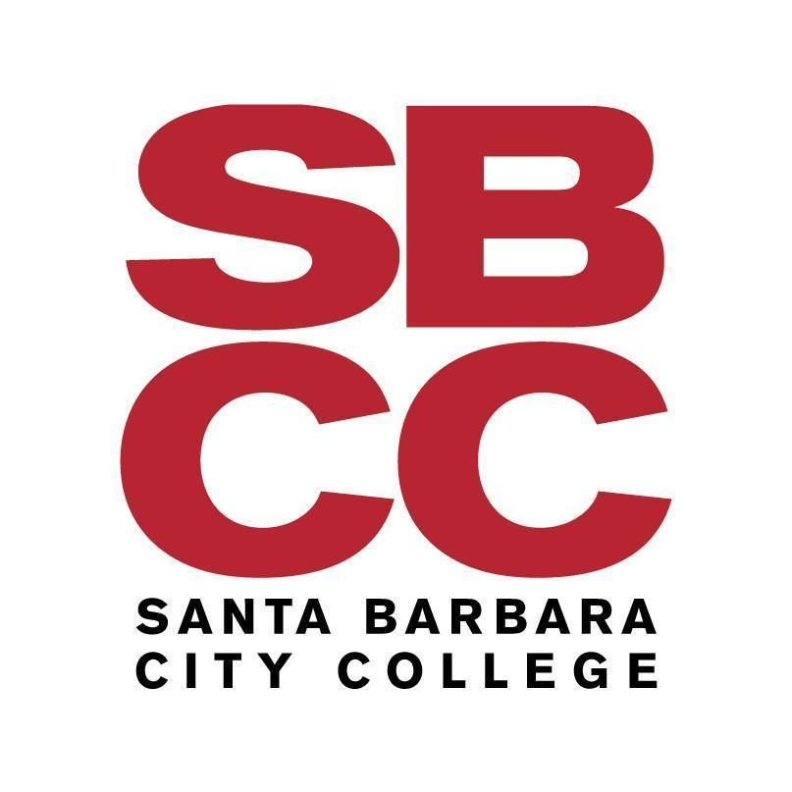

The
Outstanding Student Awards Reception

May 8, 2026
5:30 pm
SBCC Campus Center

