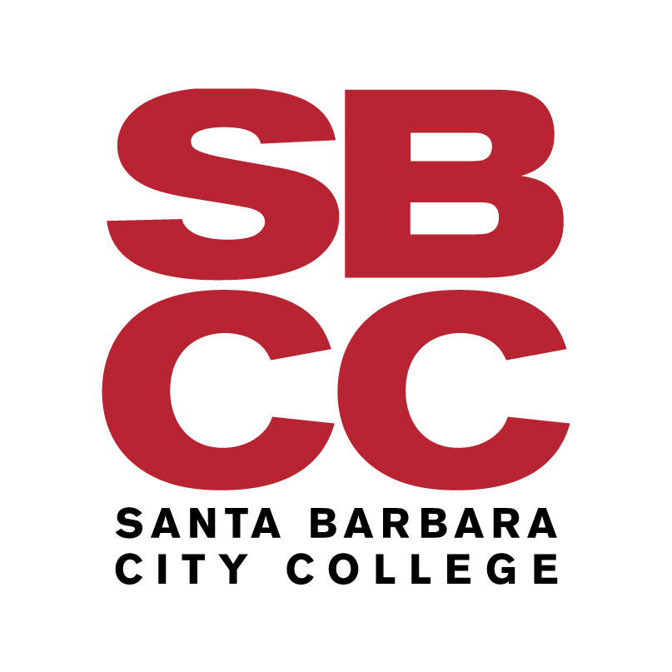
A G E N D A

SANTA BARBARA COMMUNITY COLLEGE DISTRICT

November 6, 2008

CITIZENS’ BOND OVERSIGHT COMMITTEE MEETING
4:00 pm
A218C

MacDougall Administration Center
Santa Barbara City College
721 Cliff Drive

- CALL TO ORDER AND INTRODUCTIONS
- PUBLIC COMMENTS
- ROLES AND RESPONSIBILITIES OF THE OVERSIGHT COMMITTEE
- APPOINTMENT OF CHAIR
- ELECTION OF VICE CHAIR
- ESTABLISH TERMS OF SERVICE
- ESTABLISHMENT OF MEETING DATES
- REPORT ON PROPOSED BOND ISSUE AND PROJECTS
- ADJOURNMENT

