Faculty Recognition Committee

End of Year Report: 2006-2007

May 9, 2007

The Faculty Recognition Committee had a very successful year for 2006-2007. Besides the five major awards we oversaw, and the three events we ran and participated in, there were several other significant changes we made to the committee itself.

COMMITTEE:
The ten dedicated members of the 2006-2007 Faculty Recognition Committee were Mary Lawson, Katie Laris, Jeff Meyer, Susan Mantyla, Clara Oropeza, Sheila Wiley, M’Liss Garza, Robin Goodnough, Anna Parmely, and Margaret Prothero. Our Senate Representative was Kelly Lake, and our Deans were Jane Craven and Marilyn Spaventa.

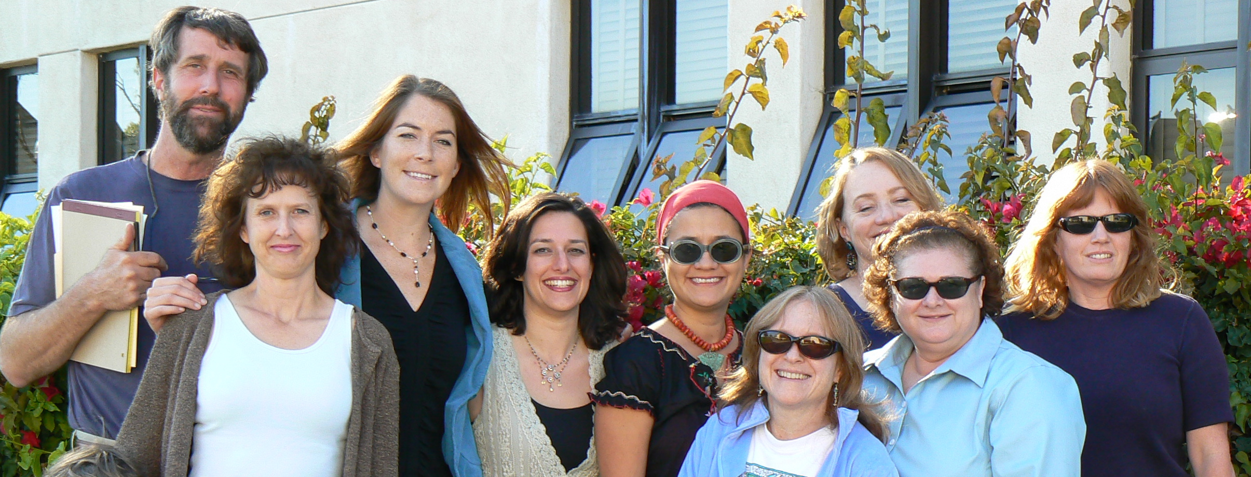

This year, each member of the FRC took on a specific role or job within the committee. For instance, each member was in charge of a complete award – from meetings with Mary Lawson to learn the ins and outs of the application procedures, to editing nomination letters and assisting our nominee with putting together his or her application. Other tasks taken on by committee members included re-writing, running, and updating our website, sending campus “Kudos to You” gold pencils, taking minutes during all our meetings, and planning our events. These were all in addition to the regular duties of the committee, which include acting as liaison for their departments and divisions for the committee, soliciting and assisting with nomination letters, reading and discussing nominations and selecting nominees.

The committee’s meetings were always well attended, productive and full of wonderful ideas and solutions. One solution we were especially pleased with relates to the increasing difficulty some faculty members face in finding the time to compose nominations for their worthy colleagues. The FRC tried to create ways to make the nomination process as streamlined, accessible, and painless as possible, so that we could receive greater numbers of nominations. To this end, we experimented with using editable fields in Word document templates that faculty could fill out online and enter electronically. We also posted all our nomination, template, and award information online. These templates also gave us committee members the ability to read nomination letters that were uniform in structure and content, and therefore more easily comparable as well.

Our website also took on drastic changes this year. Jeff Meyer worked tirelessly to redesign, rewrite, edit, update and upkeep all our committee materials online. Past award recipients, nominee’s pages, links to award websites, nomination templates, a committee website and much more are now easily found and accessible. The website can be viewed at: http://www.sbcc.edu/facultyrecognition/

EVENTS
The first event that the Faculty Recognition Committee hosted was the annual back to school (Fall Flex afternoon) party to honor the Faculty Excellence Award Recipients. This year, however, we decided to change the event instead to honor all our nominees from the past year (Hayward nominee, Stanback-Stroud nominee, etc.) Hosted at Laura Welby’s home, it was a special and moving celebration of the wonderful faculty at SBCC.

The next event was new as well. In prior years, the recipients of the Faculty Excellence Awards were given a gift basket of donated items from the Santa Barbara community. This year, however, their “gift” took on a different form. All the award recipients, as well as the SBCC nominees for our four State and National Awards, and President Romo and Vice President Friedlander, gathered together in the Gourmet Dining Room for an intimate dinner with Jack Canfield, author of the Chicken Soup for the Soul books. Mr. Canfield donated autographed copies of his book, Chicken Soul for the Teacher’s Soul, for each honoree, and gave a riveting, inspirational talk after dinner.

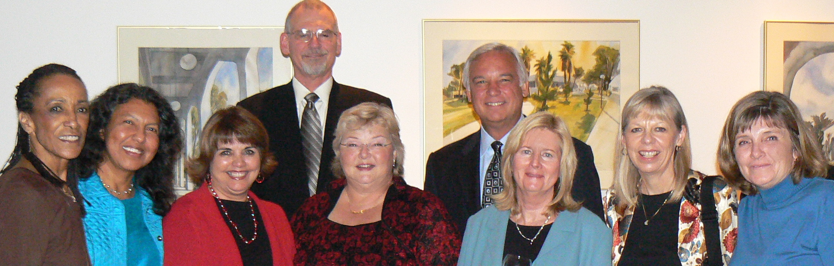

The Faculty Recognition Committee also participated in the celebration to honor the newly tenured faculty this year with Jack Friedlander’s office by attending the lovely event and by ordering engraved clocks to be presented to each tenured faculty member.

AWARDS
The following are the awards the Faculty Recognition Committee oversaw this year:

1. The Exemplary Program Award: The Citizenship Center
The Citizenship Center was awarded HONORABLE MENTION.

2. The Hayward Award: John Kay
John Kay won the award.
http://www.cccco.edu/news/press/press_2007/press_march/press_030507.htm

3. The Stanback-Stroud Diversity Award: Elida Moreno

4. The Meardy Award: Karolyn Hanna

5. The SBCC Faculty Excellence Awards for 2007-2008
Patty Saito, Biological Sciences
Fred Marschak, Earth and Planetary Sciences
Dolores Howard, English as a Second Language
Susan Broderick, Health and Wellness Program
Jody Millward, English
Maryellen Kelley, Continuing Education

Respectfully Submitted,

Margaret Prothero
Chairperson, Faculty Recognition Committee, 2006-2007
May, 2007

