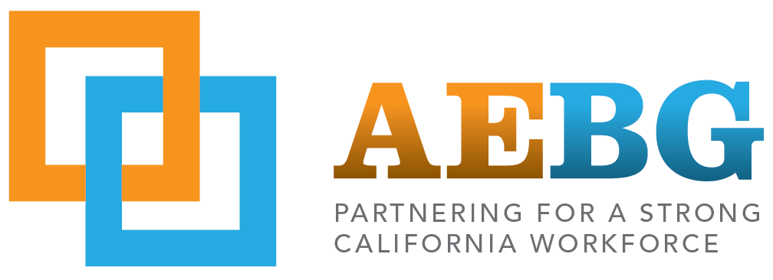

**Minutes | Santa Barbara AEBG Consortium Public Meeting**

**May 4, 2016 | SBCC Wake Campus Room 28 | 9:00am – 10:32am**

1. **Call to Order**

a. Meeting called to order at 9:00 am by Chair Melissa Moreno

1. **Roll Call & Establishment of Quorum**

a. Members present: Melissa Moreno, Ray McDonald  
b. Member absent: Tony Bauer and Micheline Miglis

c. Quorum not established.

1. **Welcome from the Chair**

I. Informational Items  
 a. AB 104 2015-2016:   
 i. Amendments due May 15  
 b. AB 104 2016-2017:   
 i. Consortium Fiscal Administration Declaration (CFAD)  
 ii. Annual Plan due mid July 2016  
 c. Save the Date: 2nd Annual AEBG Summit, October 6-7, 2016 in Sacramento

1. **Public and Entity Comment\***a. none

**V.** **Consent items** a. April 6, 2016 Public Meeting minutes moved to June 1, 2016 Public Meeting agenda.

**VI. Discussion Items**

a. YouthBuild presentation led by AEBG Program for Adults Consultant, Clarissa Morris  
 Comment: Melissa Moreno recommends to survey everything that exists and we partner with our existing   
 programs such as our SBCC Adult High School/GED program.   
 Comment: Ray McDonald is in favor of enhancing collaboration and this program to work with   
 Workforce Development Board.

b. AB 104 2015-2016: 1st Quarter Reports of Program Deliverables  
 The following programs need to submit student data to AEBG Coordinator:  
 Adult High School/GED  
 ESL/Citizenship  
 Career Skills Institute  
 Pre-Apprenticeship Construction Technology

**VII. Approval Items**

Quorum not established therefore for approval items.

**VIII. Adjournment** 10:32 am

**IX. Next Regular Meeting**

June 1, 2016  
Dark July 6, 2016