Department of Biology BMS 128
Santa Barbara City College Fall 2016

BioMed 128 - Human Nutrition
Course Outline

Instructor: Samin Moham
Email: smoham@pipeline.sbcc.edu

Course Info: CRN: 30998 Mon/Wed 6:00-7:20 pm EBS 301
Please refer to Moodle via pipeline for all class info/updates to course outline, reminders, announcements, etc.

Office Hours: Mon/Wed 7:20-8:00 pm (right after class), and by appointment as needed (Location: EBS 301, unless otherwise specified)
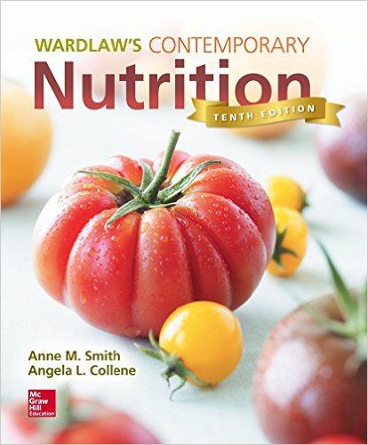
Skills Advisory: No prerequisites; Eligibility for English 110

Required Text: Wardlaw’s Contemporary Nutrition, 10th Edition
by Smith/Collene
McGraw-Hill Publishers, 2015

Course Objectives: At the completion of this course, the student will be able to:
- Summarize a basic overview of the study of human nutrition
- Describe the essential nutrients, their function, chemistry and sources
- Describe how the body uses the basic nutrients to grow and support health
- Describe the problems associated with inadequacies
- Describe the problems associated with excess nutrients
- Critically evaluate current topics in nutrition
- Discern credibility with respect to controversies in the science of nutrition, i.e., distinguish fact from fallacy
- Describe the relationship between heredity, nutrition, and health
- Assess personal dietary intake

Student Learning
Outcomes:
- BMS 128 SLO1 -- Describe the human digestive system from a nutritional perspective.
- BMS 128 SLO2 -- Discuss the chemistry, sources, and functions of essential inorganic and organic nutrients.
- BMS 128 SLO3 -- Analyze problems associated with individual nutritional deficiencies and excesses, as well as genetic, clinical, sociocultural, and global nutrition-related public health issues.
- BMS 128 SLO4 -- Appraise nutritional requirements at various stages of the human life history.

Grades and Points Distribution:

Midterm Exams ~200 pts (~100 each)
Final Exam 150 pts
In class quizzes ~60 pts
In class short summaries ~15 pts
Assignments ~30 pts
Diet Analysis Project 60 pts
Total Possible: ~515 pts

% Grade
90-100 A
80-89 B
65-79 C
56-64 D
55 and below F

The percentage may be lowered but it will never be raised. The total points for the class may be adjusted based on less/more quizzes/assignments given for the semester. Borderline grades may be bumped up based on participation, attendance, and overall improvement throughout the semester. Attendance alone does not warrant a passing grade. If you take this class for Credit/No Credit you must earn a score of 65% or above to receive Credit for the course.

Late projects/assignments:
Late assignments will not be accepted. You can always turn in your assignments earlier than the due date. If you have an emergency with appropriate documentation, you can be eligible for 50% of the assignment total if you turn it in within 24 hrs of the due date.

Exams and Quizzes:
The exams and quizzes will consist of multiple choice, true/false, matching, and a few short answer questions. Quizzes are usually announced only during class, 1-2 class sessions prior. You must be present during all exams and quizzes. If you arrive late, you may be disqualified from taking all or part of the quiz. In general, there are NO make-up exams or quizzes.

If you are absent during an exam and I do not hear from you that same day, you will receive a zero on that exam. Any arrangements to take an exam at a time outside of the scheduled date/time will require appropriate documentation and instructor approval.

Extra Credit:
There are NO extra credit assignments in this course. Please put your effort toward the material presented in the class to do the best that you can. Occasionally I may provide the opportunity to earn a few extra points but it is at my discretion.

Student Responsibilities:
You are responsible for obtaining all information given during any scheduled class meeting, including any announcements, reading material assigned from the textbook or other sources as made available on Moodle. I may make changes to the course timeline, but will notify you via email if or when I do so.

You are also expected to read and adhere to the college policy on Student Responsibilities. Some of the issues it covers are academic dishonesty, student conduct, and smoking prohibition. You can access it via the course website. Cell phones must be turned off and put away when you enter the classroom and stay off for the entire duration of the class period. Texting, emailing, and checking messages are not allowed during class time. Utilizing electronic devices that may be disruptive to class is also not allowed during class time. If you need to keep something on for a special reason please inform me before class.
Fall 2016 Important Dates to Remember:
Last Date to add class: 03-SEP-2016  Last Date to drop with a refund: 03-SEP-2016 | Last Date to drop without a "W": 05-SEP-2016  Last Date to drop with a "W": 21-OCT-2016

Communication:
If at any time you feel you are struggling in the class, please see me as soon as possible. I am here to help you be successful in this course and it is best to tackle any issues early in the semester.

If you contact me via email during the week, expect a response within 24 hours. On weekends and holidays, I will most likely get back to you on the next working day.

Accommodations for Students with Disabilities:
Disabled Student Programs and Services (DSPS) coordinates all academic accommodations for students with documented disabilities at Santa Barbara City College. If you have, or think you might have, a disability that impacts your educational experience in this class please contact DSPS to determine your eligibility for accommodations. DSPS is located in the Student Services (SS) Building, Room 162. Their phone number is 805-730-4164.
If you are already registered with DSPS please submit your accommodation requests via the ‘DSPS Online Services Student Portal’ as soon as possible. Once submitted and confirmed please visit with me about your specific accommodations.
Please complete this process in a timely manner to allow adequate time to provide accommodation.

For Course Timeline and schedule: Please see separate attachment on Moodle.

